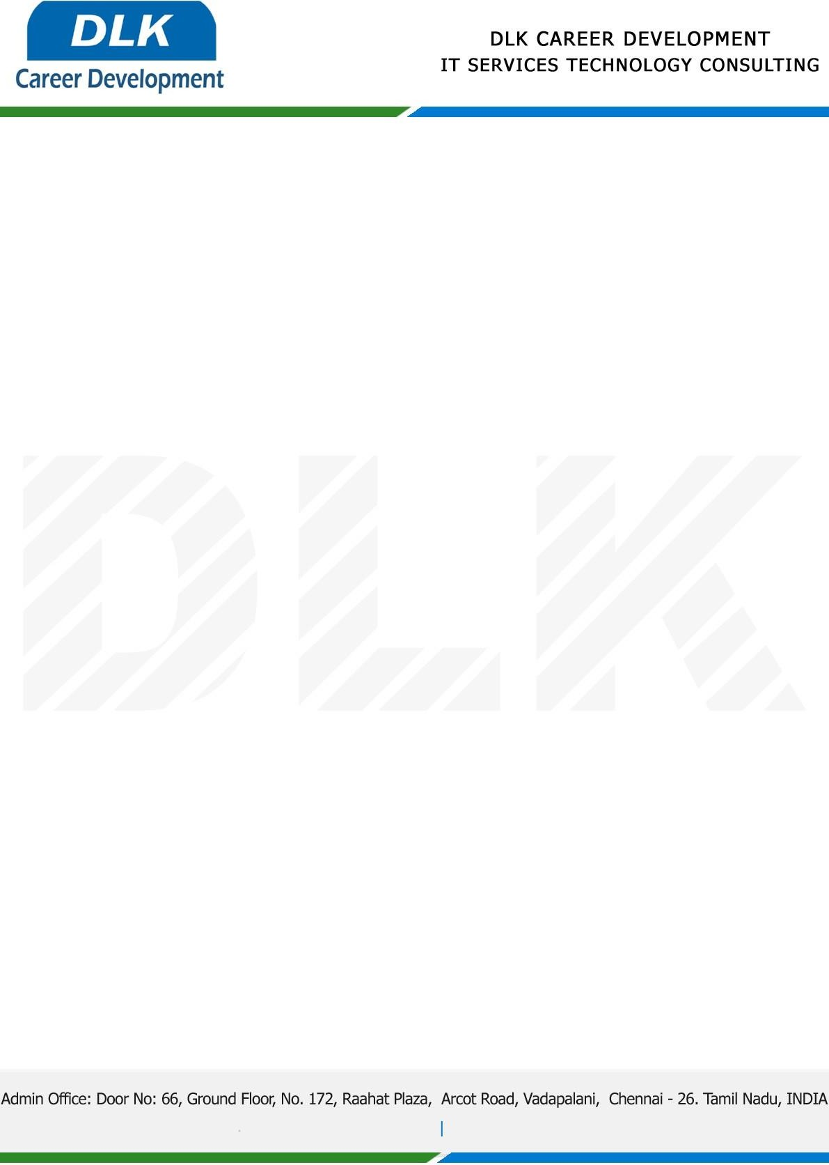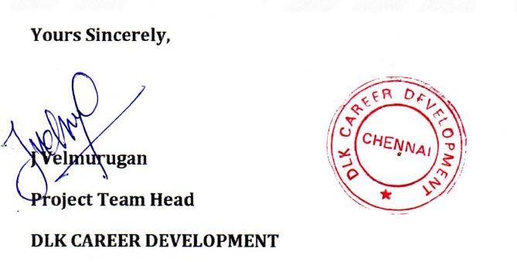

Date: 03 / January / 2022

**To**

Department of MCA ([Computer Application),](https://www.cseindia.org/) Head of Department,

Vels University, Chennai - 600117.

# Sub: Letter of Project Acceptance

This is to certify that **MR SURENDAR N (REG NO: 21304228)** that final year student of has accepted his Project Work duration from 0**4th January 2023** to **01st May 2023** under the domain **“Java”.** During the internship, all information and data collected from you should be kept confidential.

**Topic:** Smart health prediction and drug recommendation using data mining

We appreciate your interest in **DLK CAREER DEVELOPMENT**